……….
30723 Sodaville Rd Lebanon, Oregon
June 2016 Volume 6, Issue 16

City Hall (541) 258-8882 Mayor Suzie Hibbert email: sodaville@cityofsodaville.org
Web Address: www.sodaville.org Judy Smith – City Administrator
000000000000…………………………………………………………………………………………..000000000000000000000000000000

City Council Meeting City Hall Hours
7:00 pm June 16, 2016 Mon.–Thurs. 10 am–2 pm

City Update
Please be aware that the work on the Rehabilitation of the 5 City Wells is going to be taking place. Well #1 is behind the Water Compound on Ridge Street and Well #2 is located next to the compound. Well #3 is off of Sodaville-Waterloo. Wells #4 & #5 are located off of St. Louis. There will be heavy equipment going through town. The project is being funded through a grant of $129,475 from USDA and is expected to be completed by 7-15-16. This work will hopefully keep the City from having to truck in water in the future. The hope is to gain 35 gallons per minute more from the wells.

The Ford Family Foundation has awarded the City a $10,000 grant to build the Multi-Use Sport Court. Donations of labor, materials and equipment will be greatly appreciated. The City needs to match at least $4,300 in monetary donations and/or in kind contributions. Call City Hall if you can help!
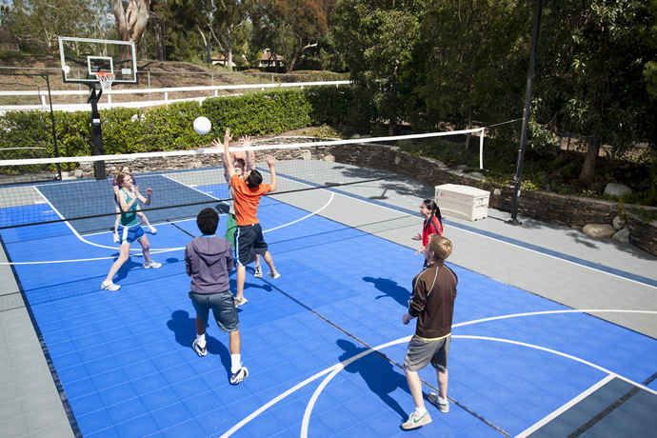

There will be a Public Hearing held for the proposed 2016-2017 Fiscal Year Budget at the Council Meeting on June 16, 2016 at 7:00 pm. If you would like a copy of the budget, please contact City Hall.

I have received several telephone calls regarding speeding around town. Calls were received regarding a black mustang coming down West View, also about cars speeding down Alder and Washington across Cottage Street. Please remember that all streets in the City are 25 mph including Sodaville Road. There are no sidewalks or bike lanes and school is now out. The Children and Adults in the City deserve a safe place to walk or bike!

Judy Smith, City Administrator
Mayor’s Message
June, the start of Summer! And The City has BIG things happening this summer! All five wells are being rehabilitated. Our wells should then more that more adequately provide water year round wit out any issues. AND The Ford Foundation gave us a grant for $10,000!! Who needs the RDI East Linn Cohort? As you may remember, they dropped our project without justifiable cause. After 6 months of work and planning. Well, we'll do it without them! If you have any experience and/or equipment, please Contact Stan Smith, he is our Project Manager. If you would like to get in on it at all, join us! This is going to be functional for all. Eventually the Soda Springs Park is going to be beautiful and something to be proud of. Have you ever driven through the little towns over in Eastern Oregon? They all have beautiful little parks with play equipment for children and picnic tables to enjoy a meal. Next we need is to get someone to buy the old store and make it into a sweet little cafe or coffee shop with WIFI... Please be sure to carry Pepsi! Hahaha.
Suzie Hibbert, Mayor mayorhibbert@gmail.com

Public Works Newsletter
These are exciting times here in the City of Sodaville. Not only is the Sport Court for the new Soda Springs Community Center Park going to become a reality but also a grant has been submitted to the OPRD (Oregon Parks and Recreation Department) for approval for the new park. If the grant is approved, there are plans for a park restroom; children’s play area, horseshoe pits and an open area for barbecue’s or gatherings to be held. Since the new park is on flat ground it is perfect for these activities. As with all grants there is plenty of competition from other Cities and there are no guaranties the City of Sodaville will receive them.

Because of last year’s drought and the City having to haul water from Lebanon to sustain levels in its reservoir, another grant has been secured for rehabilitation work on the City’s wells. That work is about to begin. In short, each well will be taken offline and rehabilitated using relatively new technologies to help water flow better into the City’s wells. The City’s goal with this work is to gain at least 35 gpm (gallons per minute) from the aquifers feeding the wells. The work involved will not affect the quality of the water being sent to the consumer in any way.

City Administrator Judy Smith is responsible for the Ford Sport Court Grant and the USDA Well Rehabilitation Grant and has helped me greatly with the OPRD Grant recently submitted. She did a Power Point presentation to the OPRD Board last Thursday about the Soda Spring Community Center Park and what the new park could look like with the grant money. Being such a small City, Judy and I both realize the importance of grants to the betterment of the City of Sodaville and its citizens. We hope you all share our vision.

Have a great summer!!

Stan Smith, Public Works Director
Country Girl Quilting
*Long-arm Machine Quilting

Call Sharon Hill and Joleana Altom at 541-401-7936

Carries Country Inn Adult Foster Home
is located at 30785 Washington Street in Sodaville.
“A safe, comfortable home where you can keep your
dignity, respect and independence.”

For information call: 541-570-1430

If you have any announcements, information or ads you wish to have published in the newsletter, please call before the 6th of the month and I will be happy to insert them! “The City of Sodaville is an equal opportunity provider and employer.”

